**Abstract**

The Word Guessing Game project aims to create an interactive and entertaining web-based game using JavaScript. The game will challenge players to guess a word based on a series of hints provided. Through a combination of intuitive user interface design and engaging gameplay mechanics, the project seeks to provide an enjoyable experience for players of all ages.

**Description**

The interactive word guessing game, developed using JavaScript, aims to captivate players with its engaging gameplay dynamics and seamless user interface. Players will immerse themselves in a challenging yet enjoyable experience as they navigate through various levels, deciphering words from a diverse range of hints provided.

At the core of the game lies its intuitive design, ensuring that players of all ages and skill levels can easily grasp the mechanics. Upon entering the game, players are greeted with a sleek and inviting interface, prompting them to embark on their word-guessing journey. The game presents a series of hints, ranging from simple clues to more cryptic riddles, challenging players to utilize their cognitive abilities and vocabulary skills to unravel the mystery word.

**Use Case**

* The Word Guessing Game serves various needs for different types of users:

1. Entertainment: For users seeking a fun and engaging activity, the game offers an entertaining way to pass the time. It provides a break from routine tasks and can be a source of relaxation and enjoyment.
2. Cognitive Exercise: The game stimulates mental activity by requiring players to think critically and creatively to decipher the hints and guess the word. It serves as a mental exercise that can improve problem-solving skills and cognitive abilities.
3. Learning and Education: Depending on the words used in the game, players can expand their vocabulary and knowledge. The game can introduce new words, concepts, or trivia, making it an educational tool for users looking to enrich their understanding of language and various subjects.
4. Social Interaction: Players can enjoy the game with friends and family, either by taking turns guessing words or by competing against each other. It fosters social interaction and can be a bonding activity during gatherings or social events.
5. Stress Relief: Playing the game can act as a stress reliever for users looking to unwind and distract themselves from daily pressures. Its simple yet engaging nature can help alleviate stress and promote relaxation.
6. Challenge and Achievement: Successfully guessing the word based on the hints provides a sense of accomplishment and satisfaction for players. It offers a challenge that motivates users to keep playing and improving their skills.
7. Accessibility: The game is easily accessible through web browsers, making it available to a wide range of users across different devices. Its intuitive interface and simple gameplay mechanics ensure that users of all ages and skill levels can enjoy it without facing any barriers to entry.
8. Overall, the Word Guessing Game caters to the diverse needs and preferences of users, offering an enjoyable and rewarding experience that can be tailored to individual preferences and goals.

**Screenshots**

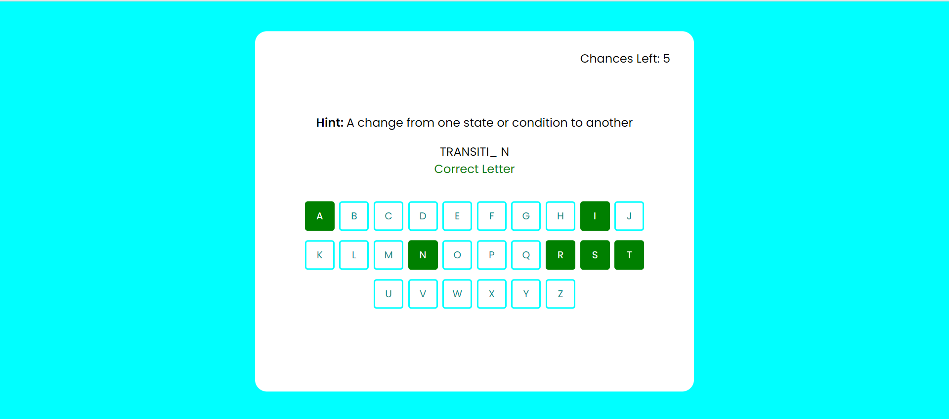

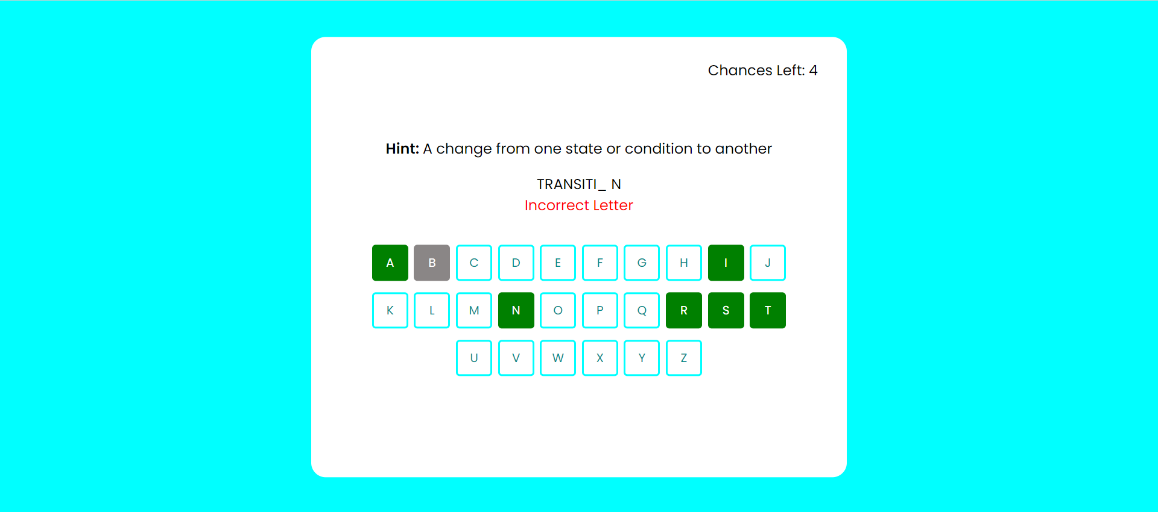



**Conclusion :-**

In conclusion, the development of the Word Guessing Game represents a harmonious amalgamation of technical expertise and creative innovation in the realm of web-based gaming. Through meticulous attention to detail and a commitment to delivering an immersive experience, this project has endeavored to create a game that not only entertains but also challenges players of all ages.